CHRISTOPHER WILLIAMS
ACTOR/SINGER

http://www.imdb.me/christopherwilliams

Christopher Williams (@realmensingcw) on Twitter

http://www.facebook.com/ChristopherWilliamsOfficial

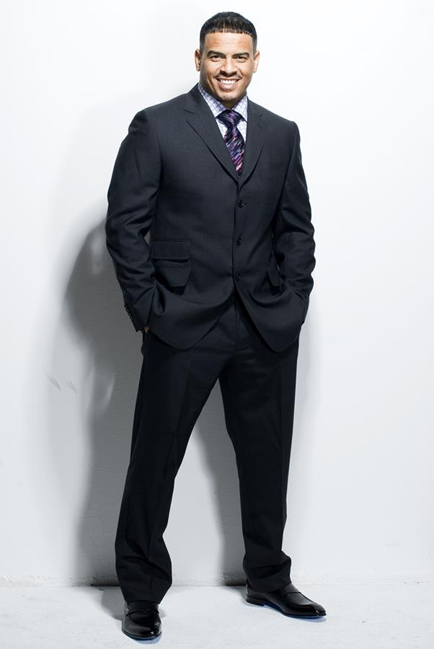

GENERAL INFORMATION
. Born and raised in the Bronx, New York
. Nephew of jazz legend- Ella Fitzgerald
. Decided to become a singer after sitting in with Aunt Ella, Frank Sinatra and Count Basie after a show
. Is a trained actor, attended performing arts college-Purchase College in NYC
. Has acted and performed in over 30 stage plays including Men Cry In The Dark, The Clean up Woman

DISCOGRAPHY
. Not Conditional / Independent 2012
. Real Men Do / Renegade 2001
. Not A Perfect Man / Giant 1995
. Changes / Uptown Records 1992
. Adventures in Paradise / Geffen 1989

MOVIES
. Revenge Of The Unhappy Campers / Ned / 2002
. Bullet Proof / performer- ‘Tha 2 Of Us”/ 1996
. Gunmen / Special appearance / 1993
. New Jack City / Kareem Akbar / 1991

TELEVISION
. Life After / (TV One) / featured 2011
. Way Black When / 1 episode- (TV One) 2011/ Himself-performer
. The Love You Save / pilot- (GMC) 2011/ Billy
. Hawthorne / 1 episode- (TNT) 2009/ Detective
. New York Undercover / 1 episode- (Fox) 1995/ Shooter

Christopher Williams has a voice that is as rich as brewed coffee-full, robust, leaves you craving for more. Just like quality coffee- his music has a way of comforting you. Making you feel warm all over all the while energizing you for more. In a time when musical tastes are changing faster than ever, it is comforting to know that singers like Christopher Williams are never changing but evolving and just getting better with time.
Raised in the Bronx, NY. Christopher Williams attended Mt. Zion Baptist Church in New York with his grandparents. While singing in the church choir his grandmother proclaimed what was already proven to be his God given gift -“This boy can Sing!”-and with those words would eventually prove to be prophetic for Williams and lead him into a full fledged music career.
In 1974, after watching an inspirational live performance of his aunt, legendary singer- Ella Fitzgerald performing with Count Basie and Frank Sinatra, Christopher Williams’ fate had been set. It was more than the feeling he had seeing his favorites such as The Jackson Five, Teddy Pendergrass and Aretha Franklin at the world-famous Apollo Theater with his mother and sister. This feeling was different, while sitting at the piano with Frank Sinatra and Count Basie that night, a young Williams felt- “Wow, This is so amazing! I want to do this one day.”
Before getting a record deal, Christopher Williams decided that if he was going to make entertainment a tangible career, he would put in real work and real effort to learn his craft -he enrolled in Purchase College in New York City- a performing arts school where he studied theater arts and acting.

Two years later, while still in school, Williams decided to try his hand at music. He recorded an impressive two song demo: Remember, with Amir and Royal Bayyan and I’m Your Present produced by Timmy Allen (who went on to produce artists such as Brittany Spears, Backstreet Boys and R. Kelly).

This demo led to Williams’ signing his first record deal with Geffen Records setting off the beginning of Williams’ success as a singer with the release of his first album Adventures in Paradise. Adventures in Paradise included the chart topping and unforgettable hits- Promises Promises and Talk to Myself.

In 1991 Christopher Williams streak of musical success continued with a move to Uptown Records and his sophomore album Changes. Williams topped the charts with four singles- All I See, Every Little Thing You Do, Come On and Go with Me and Dreamin. That same year, Williams had the opportunity to add acting to his growing list of successes and starred in the now cult classic, hip hop film- New Jack City, starring his Purchase College classmate- Wesley Snipes. The film opened, nationwide, to rave box office sales and reviews. It was official- Christopher Williams was a superstar!
As Christopher Williams matured and grew, as did the direction and style of the type of music he wanted to produce, so in 1995 Christopher Williams signed with Giant Records and recorded his third studio album- Not A Perfect Man which spawned the hit Dance 4 Me.In 2002, Williams recorded his fourth project- Real Men Do on his own label, August/Renegade Records.

Christopher Williams list of credits include producing and performing on the award winning and multi-platinum selling motion picture soundtracks- Jason’s Lyric, New Jack City, Butter, The Nutty Professor and Gun Men. Christopher Williams has starred in some of the most successful gospel stage plays to date- including Men Cry In The Dark, and The Clean Up Woman

To add even more fuel to the superstar flame that Williams wouldn’t let settle- in between plays and touring, Williams is recording his fifth studio release, much to the excitement of his millions of fans and followers. Hitting the studio with the likes of superstar producers like Ced Solo, Mike City, Da Internz, Carvin & Ivan and 9th Wonder is just another “day at the office” for Williams just another day of going above and beyond and taking no prisoners- giving his all still being “More than a Conqueror.”

Enter 2012 and Christopher Williams is still on top working hard as ever. Christopher Williams has remained humbled yet hungry to continuously perfect his craft musically and theatrically.

