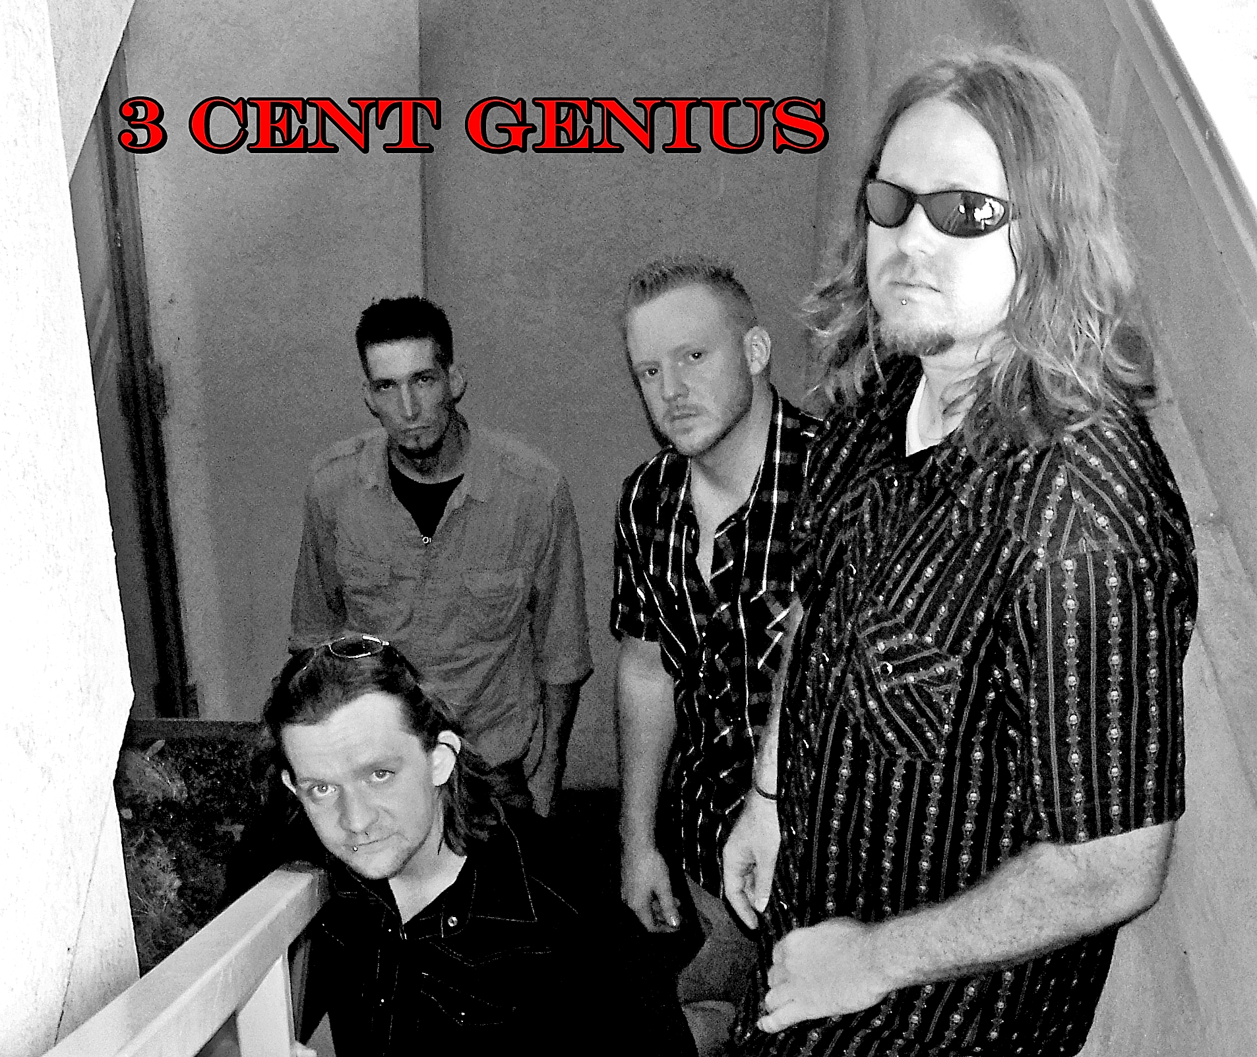

Bio

“Every so often, the right combination of talented musicians come together to form a band”

3¢ Genius was formed in June 2010 by members, “Gabe Cunningham” - Vocals & Guitar, “Lee Yandell” - Vocals & Guitar, “Damon Shores” - Bass, and “Mike Martin” - Drums. 3¢ Genius is by far a rare gathering of seasoned, talented musicians driven by their love for making music and entertaining their loyal fans. This group is based out of Fort Smith, AR and considers Eastern Oklahoma and Western Arkansas home. 3¢ Genius is a “rock” cover/original band that performs hits from the 80’s, 90’s, and 2000’s. With such a broad catalog of music, 3¢ Genius can please the most discriminating crowds.

